Telomerase

Actually at each division, there is a lose of a small part at the end of the chromosome, it is called the telomere. And stem cells replicates many times in their all life, indeed they need an enzyme that rebulid this telomere, this one is named telomerase.

Before replication
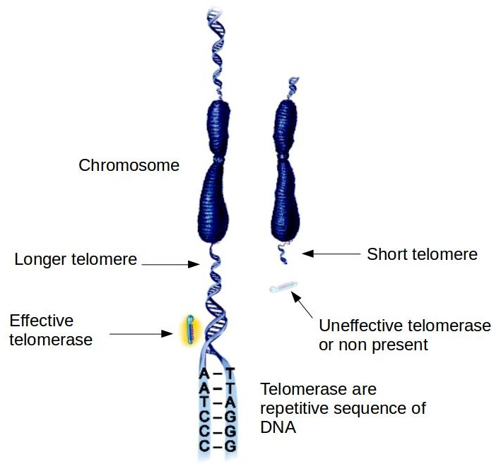
On this picture, both situation are represented : when there is effective telomerase and telomere is rebuilt on the left and when there isn't telomerase and in this case chromosome is shorter.

Positioning of telomerase
Before intervention of telomerase the chromosome of the daughter cell is shorter than the mother's one. Then the telomerase comes with its strand of RNA.
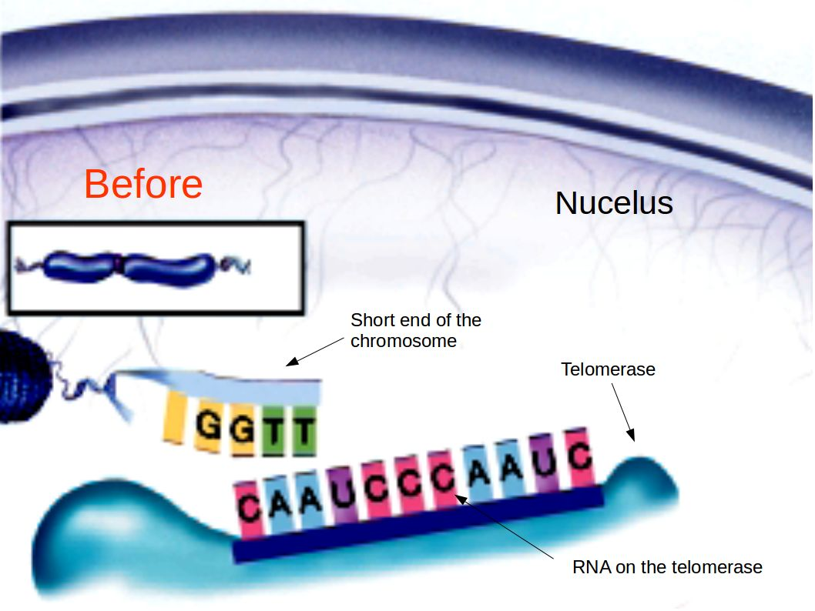

DNA polymerase
Then de DNA polymerase complete the chromosome strand with complementary nucleotides with the telomere RNA strand.
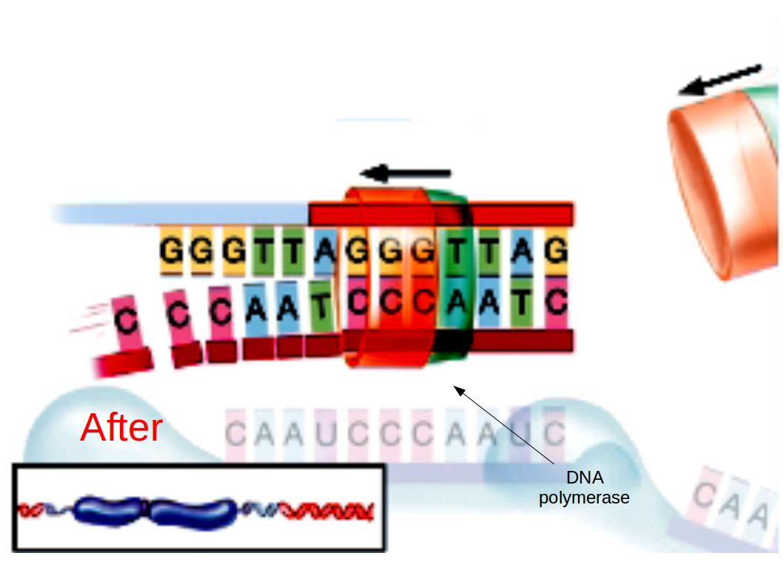
Finally, the daughter's cell chromosome is as long as her mother's.

